**Install JDK on Ubuntu**

The Hadoop framework is written in [**Java**](https://phoenixnap.com/glossary/java-definition), and its services require a compatible Java Runtime Environment (JRE) and Java Development Kit (JDK). Use the following command to update your system before initiating a new installation:

sudo apt updateCopy

At the moment, **Apache Hadoop 3.x fully supports Java 8** and **11**. The OpenJDK 8 package in Ubuntu contains both the [**runtime environment**](https://phoenixnap.com/glossary/runtime-environment) and development kit.

Type the following command in your terminal to install OpenJDK 8:

sudo apt install openjdk-8-jdk -yCopy

**Note:** The OpenJDK or Oracle Java version can affect how elements of a Hadoop ecosystem interact. To install a specific Java version, check out our detailed guide on [**how to install Java on Ubuntu**](https://phoenixnap.com/kb/how-to-install-java-ubuntu).

Once the installation process is complete, [**verify the current Java version**](https://phoenixnap.com/kb/check-java-version-linux):

java -version; javac -versionCopy

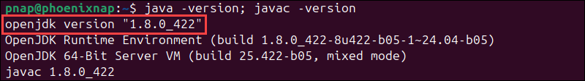

The output informs you which Java version is in use.

**Set Up Hadoop User and Configure SSH**

It is advisable to create a non-root user, specifically for the Hadoop environment. A distinct user improves security and helps you manage your cluster more efficiently. To ensure the smooth functioning of Hadoop services, the user should have the ability to establish a **[passwordless SSH connection](https://phoenixnap.com/kb/setup-passwordless-ssh" \t "_blank)** with the [**localhost**](https://phoenixnap.com/kb/127-0-0-1-localhost).

**Install OpenSSH on Ubuntu**

Install the OpenSSH server and client using the following command:

sudo apt install openssh-server openssh-client -yCopy

In the example below, the output confirms that the latest version is already installed.

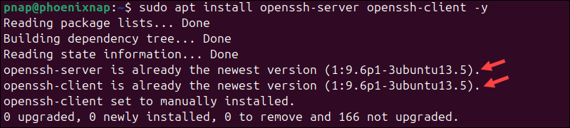

**Note:** If you have installed OpenSSH for the first time, use this opportunity to learn about [**Linux SSH security**](https://phoenixnap.com/kb/linux-ssh-security) best practices.

**Create Hadoop User**

Utilize the **[adduser command](https://phoenixnap.com/kb/linux-adduser" \t "_blank)** to create a new Hadoop user:

sudo adduser hdoopCopy

The username, in this example, is **hdoop**. You are free to use any username and password you see fit.

**Tip:** Check out our [**strong password ideas**](https://phoenixnap.com/blog/strong-great-password-ideas) or try our [**free password generator**](https://phoenixnap.com/kb/password-generator).

Switch to the newly created user and enter the corresponding password:

su - hdoopCopy

The user now needs to be able to SSH to the localhost without being prompted for a password.

**Enable Passwordless SSH for Hadoop User**

[**Generate an SSH key pair**](https://phoenixnap.com/kb/generate-setup-ssh-key-ubuntu) and define the location it is to be stored in:

ssh-keygen -t rsa -P '' -f ~/.ssh/id\_rsaCopy

The system proceeds to generate and save the SSH key pair.

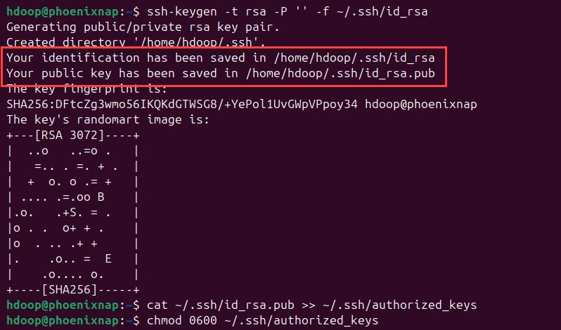

Use the [**cat command**](https://phoenixnap.com/kb/linux-cat-command) to store the public key as **authorized\_keys**in the *ssh* [**directory**](https://phoenixnap.com/glossary/what-is-a-directory):

cat ~/.ssh/id\_rsa.pub >> ~/.ssh/authorized\_keysCopy

Set the [**file permissions**](https://phoenixnap.com/kb/linux-file-permissions) for your user with the **chmod** command:

chmod 0600 ~/.ssh/authorized\_keysCopy

The new user can now SSH without entering a password every time. Verify everything is set up correctly by using the **hdoop** user to SSH to localhost:

ssh localhostCopy

After an initial prompt, the Hadoop user can seamlessly establish an SSH connection to the localhost.

**Download and Install Hadoop on Ubuntu**

After configuring the Hadoop user, you are ready to install Hadoop on your system. Follow the steps below:

1. Visit the [**official Apache Hadoop project page**](https://hadoop.apache.org/releases.html) and select the version of Hadoop you want to implement.

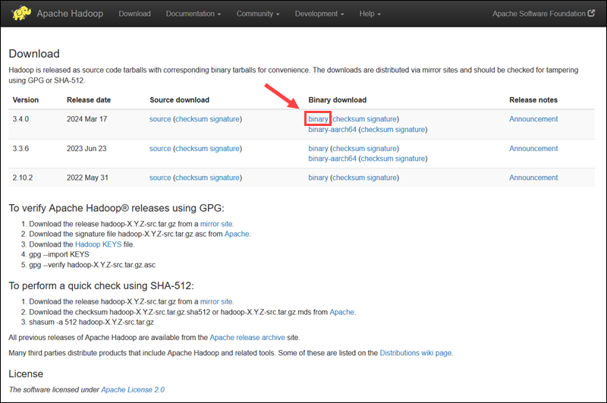

The steps outlined in this tutorial use the [**binary**](https://phoenixnap.com/glossary/binary-file) download for **Hadoop Version 3.4.0**. Select your preferred option, and you will be presented with a mirror link to download the **Hadoop**tar package.

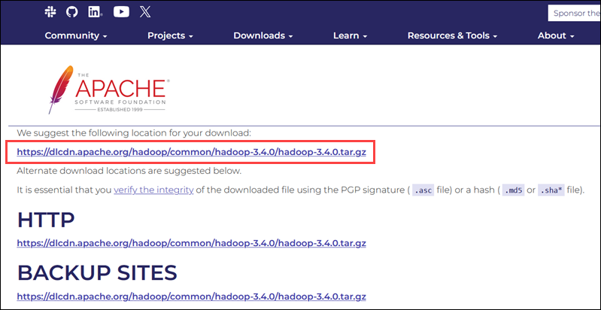

**Note:** It is sound practice to verify Hadoop downloads originating from mirror sites. The instructions for using GPG or SHA-512 for verification are provided on the official download page.

2. Use the provided mirror link and download the Hadoop package using the **[wget command](https://phoenixnap.com/kb/wget-command-with-examples" \t "_blank)**:

wget https://dlcdn.apache.org/hadoop/common/hadoop-3.4.0/hadoop-3.4.0.tar.gzCopy

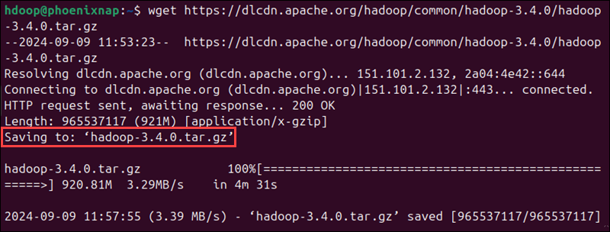

3. Once the download completes, use the [**tar command**](https://phoenixnap.com/kb/tar-command-in-linux) to [**extract the .tar.gz file**](https://phoenixnap.com/kb/extract-tar-gz-files-linux-command-line) and initiate the Hadoop installation:

tar xzf hadoop-3.4.0.tar.gzCopy

The Hadoop binary [**files**](https://phoenixnap.com/glossary/what-is-a-file) are now located within the *hadoop-3.4.0* directory.

**Single Node Hadoop Deployment (Pseudo-Distributed Mode)**

Hadoop excels when deployed in a **fully distributed mode** on a large cluster of networked servers*.* However, if you are new to Hadoop and want to explore basic commands or test applications, you can configure Hadoop on a single node.

This setup, also called **pseudo-distributed mode**, allows each Hadoop [**daemon**](https://phoenixnap.com/glossary/what-is-a-daemon) to run as a single Java process. Configure a Hadoop environment by editing a set of [**configuration files**](https://phoenixnap.com/glossary/config-file):

* [**.bashrc**](https://phoenixnap.com/kb/bashrc)
* *hadoop-env.sh*
* *core-site.xml*
* *hdfs-site.xml*
* *mapred-site-xml*
* *yarn-site.xml*

**Configure Hadoop Environment Variables (bashrc)**

The *.bashrc* config file is a shell [**script**](https://phoenixnap.com/glossary/what-is-a-script) that initializes user-specific settings, such as environment variables, aliases, and functions, every time a new Bash shell session is started. Follow the steps below to configure Hadoop environment variables:

1. Edit the *.bashrc* shell configuration file using a [**text editor**](https://phoenixnap.com/kb/best-linux-text-editors-for-coding) of your choice (we will use [**nano**](https://phoenixnap.com/kb/use-nano-text-editor-commands-linux)):

nano .bashrcCopy

2. Define the Hadoop environment variables by adding the following content to the end of the file:

#Hadoop Related Options

export HADOOP\_HOME=/home/hdoop/hadoop-3.4.0

export HADOOP\_INSTALL=$HADOOP\_HOME

export HADOOP\_MAPRED\_HOME=$HADOOP\_HOME

export HADOOP\_COMMON\_HOME=$HADOOP\_HOME

export HADOOP\_HDFS\_HOME=$HADOOP\_HOME

export YARN\_HOME=$HADOOP\_HOME

export HADOOP\_COMMON\_LIB\_NATIVE\_DIR=$HADOOP\_HOME/lib/native

export PATH=$PATH:$HADOOP\_HOME/sbin:$HADOOP\_HOME/bin

export HADOOP\_OPTS="-Djava.library.path=$HADOOP\_HOME/lib/native"Copy

3. Once you add the variables, save and exit the *.bashrc* file.

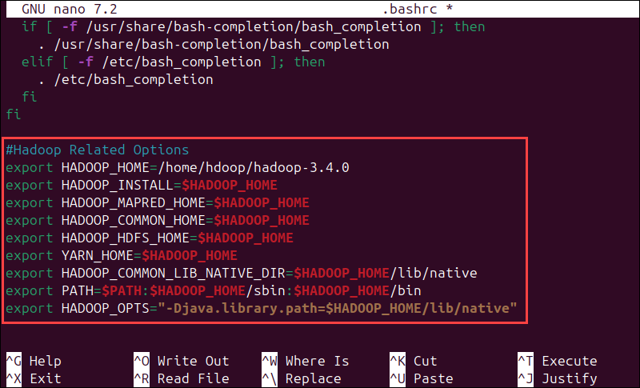

4. Run the command below to apply the changes to the current running environment:

source ~/.bashrcCopy

**Edit hadoop-env.sh File**

The *hadoop-env.sh* file serves as a master file to configure YARN, [**HDFS**](https://phoenixnap.com/kb/what-is-hdfs), [**MapReduce**](https://phoenixnap.com/kb/hadoop-mapreduce), and Hadoop-related project settings. When setting up a **single-node Hadoop cluster**, you need to define which Java implementation will be utilized.

Follow the steps below:

1. Use the previously created **$HADOOP\_HOME** variable to access the *hadoop-env.sh* file:

nano $HADOOP\_HOME/etc/hadoop/hadoop-env.shCopy

2. Uncomment the **$JAVA\_HOME** variable (i.e., remove the **#** sign) and add the full path to the OpenJDK installation on your system. If you have installed the same version as presented in the first part of this tutorial, add the following line:

export JAVA\_HOME=/usr/lib/jvm/java-8-openjdk-amd64Copy

The path needs to match the location of the Java installation on your system.

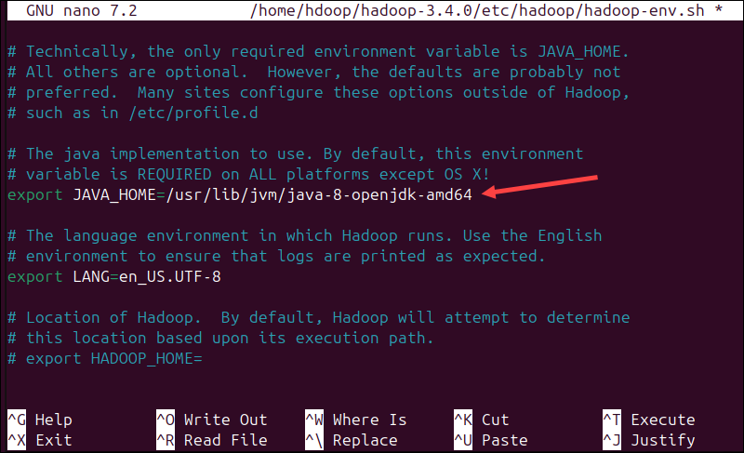

If you need help to locate the correct Java path, run the following command in your terminal window:

which javacCopy

The resulting output provides the path to the Java binary directory.

Finding the path to the Java binary directory on an Ubuntu system.

3. Use the provided path to find the OpenJDK directory with the following command:

readlink -f /usr/bin/javacCopy

The section of the path just before the */bin/javac* directory needs to be assigned to the **$JAVA\_HOME** variable.

Path to OpenJDK directory that need to be added to the $JAVA_HOME variable in Hadoop.

**Edit core-site.xml File**

The *core-site.xml* file defines HDFS and Hadoop core properties. To set up Hadoop in a pseudo-distributed mode, you need to specify the [**URL**](https://phoenixnap.com/glossary/url-definition-meaning) for your NameNode, and the temporary directory Hadoop uses for the map and reduce process.

The steps below show how to configure the file.

1. Open the *core-site.xml* file in a text editor:

nano $HADOOP\_HOME/etc/hadoop/core-site.xmlCopy

2. Add the following configuration to override the default values for the temporary directory and add your HDFS URL to replace the default local file system setting:

<configuration>

<property>

<name>hadoop.tmp.dir</name>

<value>/home/hdoop/tmpdata</value>

</property>

<property>

<name>fs.default.name</name>

<value>hdfs://127.0.0.1:9000</value>

</property>

</configuration>Copy

This example uses values specific to the local system. You should use values that match your system's requirements. The data needs to be consistent throughout the configuration process.

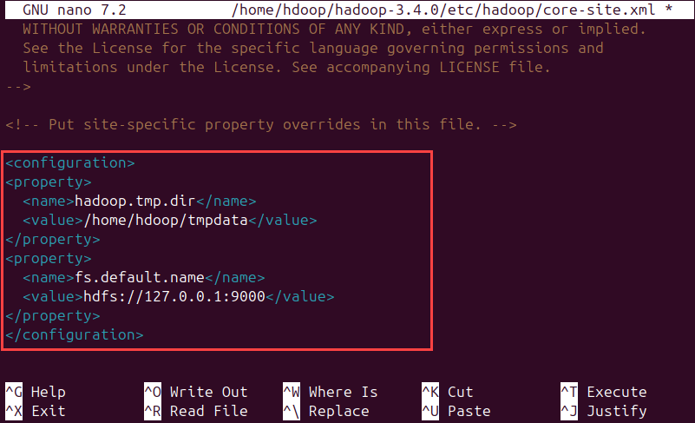

Do not forget to [**create a directory**](https://phoenixnap.com/kb/create-directory-linux-mkdir-command) in the location you specified for your temporary data.

**Edit hdfs-site.xml File**

The *hdfs-site.xml* file governs specifies critical parameters, such as [**data storage**](https://phoenixnap.com/kb/what-is-data-storage) paths, replication settings, and block sizes, which govern the behavior and performance of the HDFS cluster. Configure the file by defining the **NameNode**and**DataNode storage directories**. Additionally, the default **dfs.replication** value of **3** needs to be changed to **1** to match the single-node setup.

Follow the steps below:

1. Use the following command to open the *hdfs-site.xml* file for editing:

sudo nano $HADOOP\_HOME/etc/hadoop/hdfs-site.xmlCopy

2. Add the following configuration to the file and, if needed, adjust the NameNode and DataNode directories to your custom locations:

<configuration>

<property>

<name>dfs.data.dir</name>

<value>/home/hdoop/dfsdata/namenode</value>

</property>

<property>

<name>dfs.data.dir</name>

<value>/home/hdoop/dfsdata/datanode</value>

</property>

<property>

<name>dfs.replication</name>

<value>1</value>

</property>

</configuration>Copy

If necessary, create the specific directories you defined for the **dfs.data.dir** value.

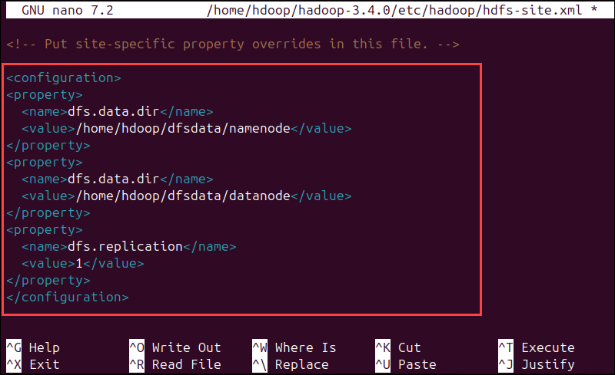

**Edit mapred-site.xml File**

The *mapred-site.xml* file is a configuration file that defines settings for the MapReduce framework, including parameters such as the job tracker address, the number of map and reduce tasks, and resource management, to control how MapReduce jobs are executed across the cluster.

Follow the steps below to configure the *mapred-site.xml* file:

1. Use the following command to access the *mapred-site.xml*file and **define MapReduce values**:

sudo nano $HADOOP\_HOME/etc/hadoop/mapred-site.xmlCopy

2. Add the following configuration to change the default MapReduce framework name value to **yarn**:

<configuration>

<property>

<name>mapreduce.framework.name</name>

<value>yarn</value>

</property>

</configuration>Copy

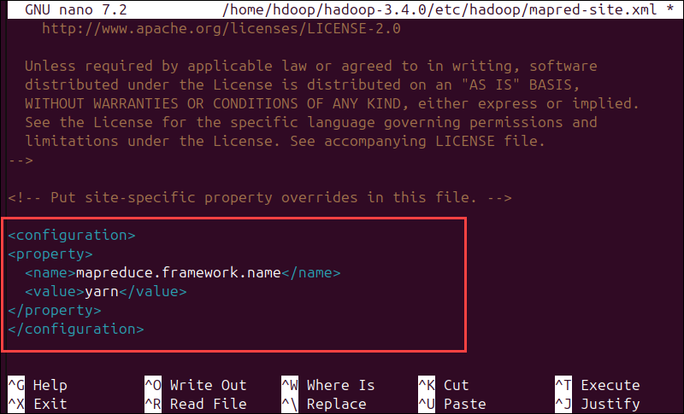

**Edit yarn-site.xml File**

The *yarn-site.xml* file defines YARN settings. It contains configurations for the **Node Manager, Resource Manager, Containers,** and **Application Master**.

1. Open the *yarn-site.xml* file in a text editor:

nano $HADOOP\_HOME/etc/hadoop/yarn-site.xmlCopy

2. Append the following configuration to the file:

<configuration>

<property>

<name>yarn.nodemanager.aux-services</name>

<value>mapreduce\_shuffle</value>

</property>

<property>

<name>yarn.nodemanager.aux-services.mapreduce.shuffle.class</name>

<value>org.apache.hadoop.mapred.ShuffleHandler</value>

</property>

<property>

<name>yarn.resourcemanager.hostname</name>

<value>127.0.0.1</value>

</property>

<property>

<name>yarn.acl.enable</name>

<value>0</value>

</property>

<property>

<name>yarn.nodemanager.env-whitelist</name>

<value>JAVA\_HOME,HADOOP\_COMMON\_HOME,HADOOP\_HDFS\_HOME,HADOOP\_CONF\_DIR,CLASSPATH\_PERPEND\_DISTCACHE,HADOOP\_YARN\_HOME,HADOOP\_MAPRED\_HOME</value>

</property>

</configuration>Copy

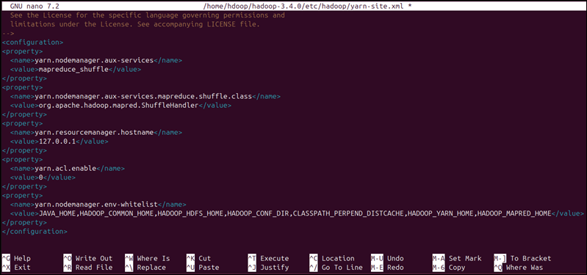

**Format HDFS NameNode**

It is important to **format the NameNode** before starting Hadoop services for the first time:

hdfs namenode -formatCopy

The shutdown notification signifies the end of the NameNode format process.

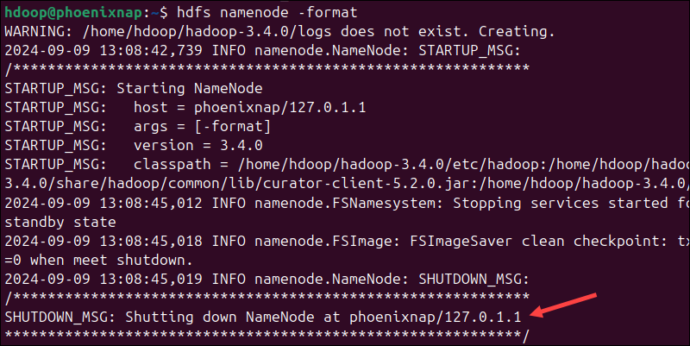

**Start Hadoop Cluster**

Starting a Hadoop cluster involves initializing the key services - HDFS for distributed storage and YARN for resource management. This enables the system to process and store large-scale data across multiple nodes.

Follow the steps below:

1. Navigate to the *hadoop-3.4.0/sbin* directory and execute the following command to start the NameNode and DataNode:

./start-dfs.shCopy

The system takes a few moments to initiate the necessary nodes.

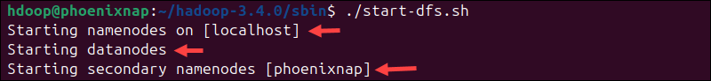

2. Once the *namenode*, *datanodes*, and *secondary* *namenode* are up and running, start the YARN resource and *nodemanagers* by typing:

./start-yarn.shCopy

As with the previous command, the output informs you that the processes are starting.



3. Run the following command to check if all the daemons are active and running as Java processes:

jpsCopy

If everything works as intended, the resulting list of running Java processes contains all the HDFS and YARN daemons.

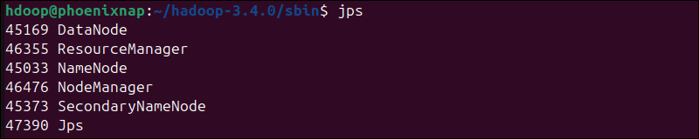

**Access Hadoop from Browser**

Use your preferred [**browser**](https://phoenixnap.com/glossary/web-browser-definition) and navigate to your localhost URL or IP. The default [**port number**](https://phoenixnap.com/glossary/port-number) **9870** gives you access to the Hadoop NameNode [**UI**](https://phoenixnap.com/glossary/what-is-ui-user-interface):

http://localhost:9870Copy

The NameNode user interface provides a comprehensive overview of the entire cluster.

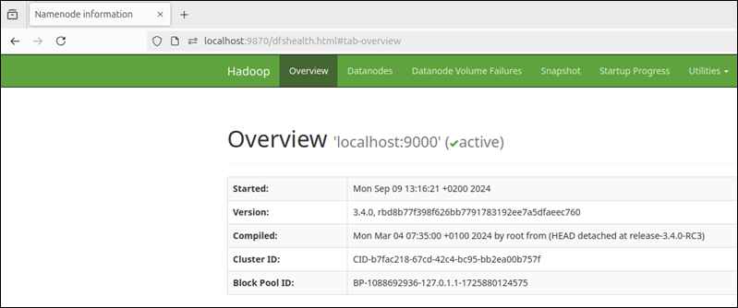

The default [**port**](https://phoenixnap.com/glossary/what-is-a-port) **9864** is used to access individual DataNodes directly from your browser:

http://localhost:9864Copy

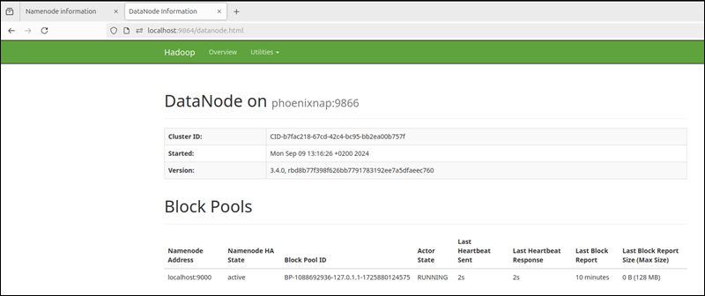

The YARN Resource Manager is accessible on port **8088**:

http://localhost:8088Copy

The Resource Manager is an invaluable tool that allows you to monitor all running processes in your Hadoop cluster.

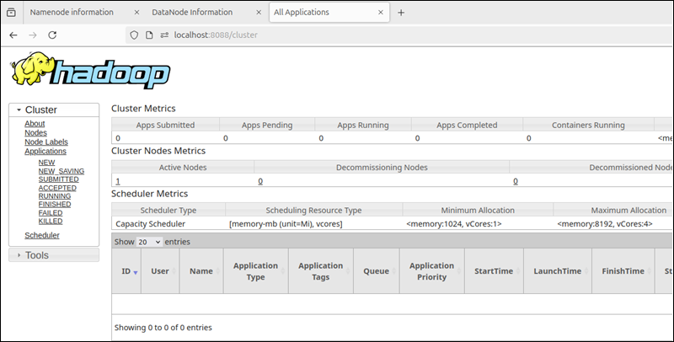

**[](https://phoenixnap.com/colocation/phoenix?utm_source=knowledge-base&utm_medium=banner&utm_campaign=sysadmin-desktop-incontent)**

pip install notebook

jupyter notebook

pip install hdfs